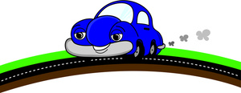
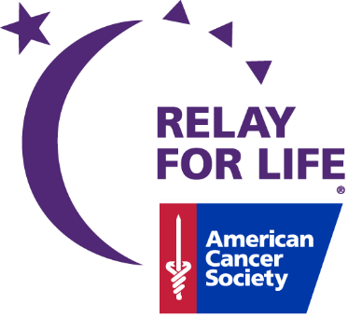

3nd Annual Road Rally
For a Cure!

New Baltimore’s Relay for Life
Is hosting a Picture/Puzzle Road Rally
April 21, 2018 from 4:00 – 7:00

A challenging night of fun, friendships, and excitement! Take a ride around New Baltimore and the surrounding area solving riddles, puzzles, and taking pictures!!
Info for Rally:
- Need a smart phone with QR reader App
- Camera (smart phone is ok)
- Check-in at 4:00 at
Hot Tamales Cantina 33151 23 Mile Rd
(Next to Premier Bowling Alley)

$50 per car – max 5 people per car
All ages welcome – each vehicle needs a licensed driver.
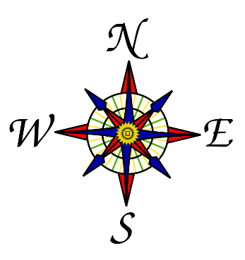
Pizza and beverages will be provided at the ending of the rally at
Hot Tamales
Reserve your spot today by contacting
Phil Ricci at pricci@abs.misd.net

Please REGISTER BY APRIL 14

